Paint

**Team Names:**

* Ziad Hisham Ali Abdel-Hameed Saad (19)
* Youssef Ahmed Sayed Gabriel (61)

Report:

**Description:**

* It’s the famous paint program that we use to draw different shapes e.g. Circles, Ellipses, Rectangle ….etc., with plugin support and with a lot of features such as move, resize, multi shape copy, paste & coloring …etc., and the handy undo & redo functionality with the ability to save & load the user’s work at anytime.

**Features:**

1. Built using the visually appealing JavaFX GUI.
2. Draw shapes with 6 standard shapes and a plugin support for adding shapes from jar files.
3. Resize, move and multi shape copy, paste & coloring.
4. Drawing & moving shapes by Mouse dragging for more accurate drawing.
5. Keyboard shortcuts :
   1. Ctrl + Z “Undo”
   2. Ctrl + Y “Redo”
   3. Ctrl + C “Copy”
   4. Ctrl + V “Paste”
   5. Ctrl + S “Save”
   6. Ctrl + L “Load”

**UML (Design):**

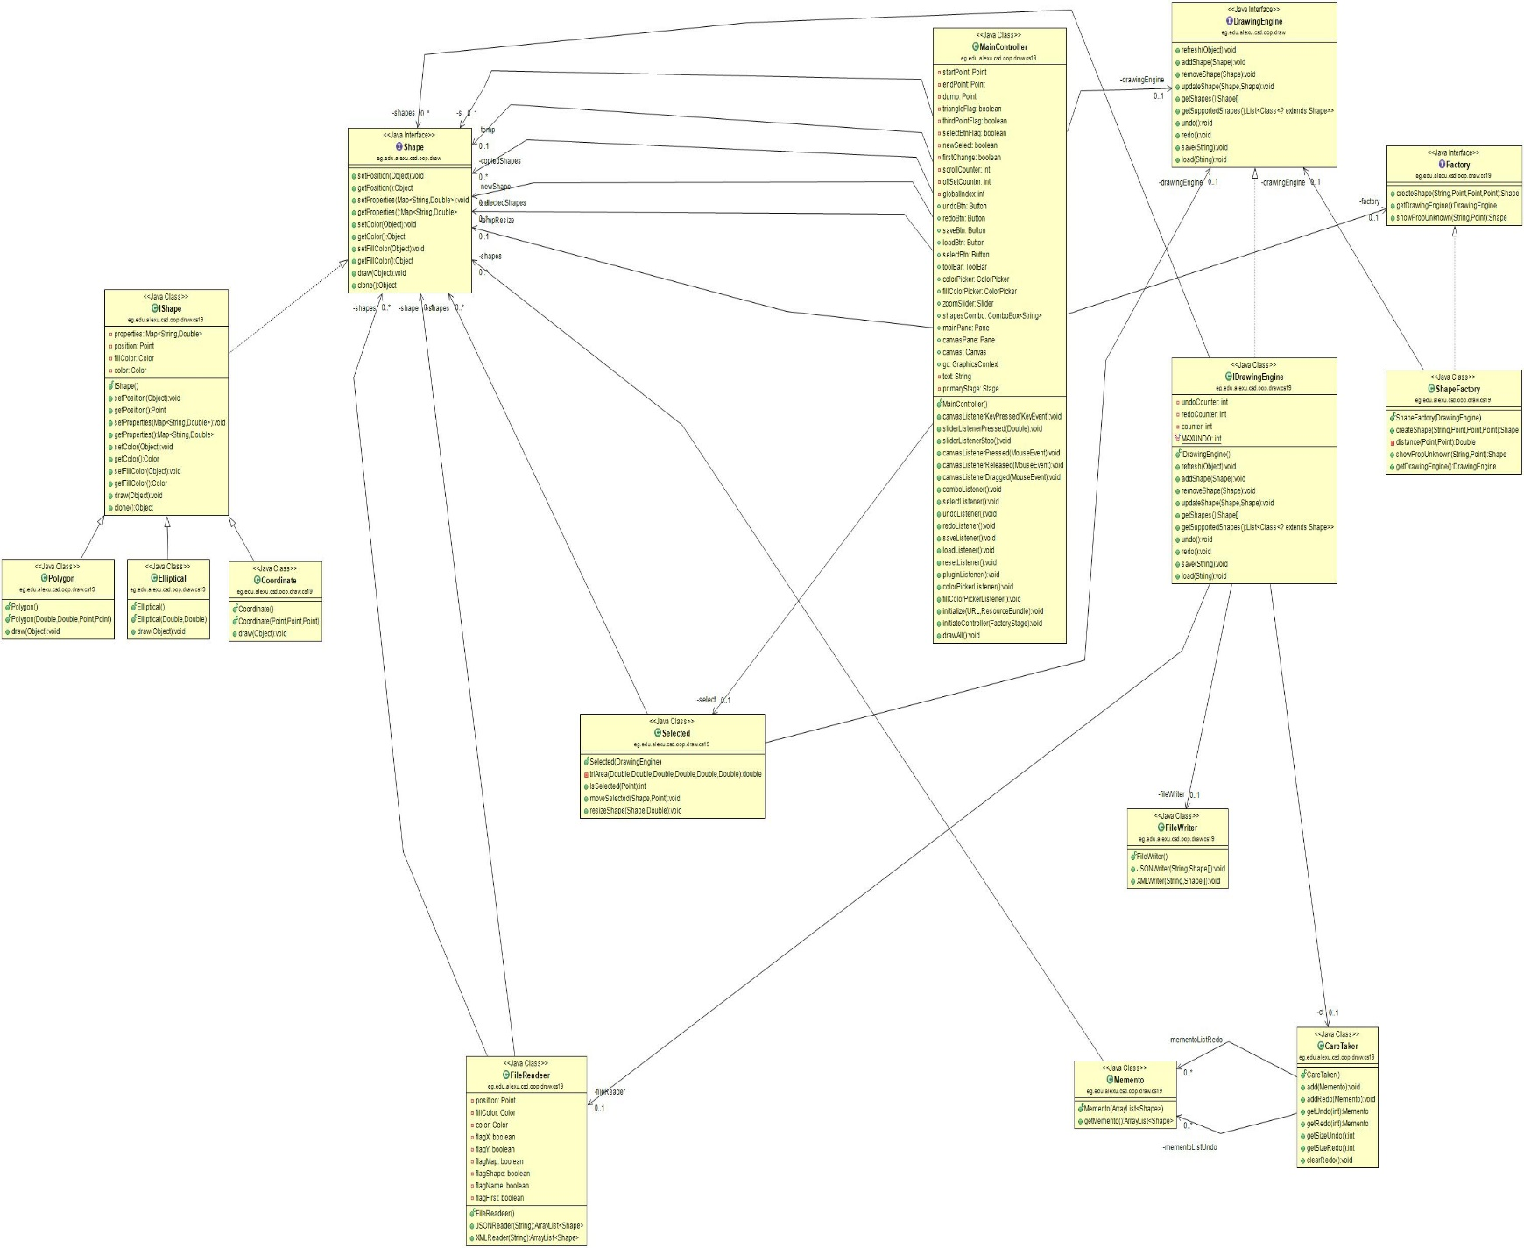

**Assumptions:**

* The multi selection of the shapes supports copy, Paste & coloring only.
* The resize of the polygons is done by fixing one point and enlarging the other points.
* Any added shape using the plugin feature will only be drawn if it supports JavaFX Graphics.

**User Manual:**

* When the program opens, select from the combo box the shape you want to draw.
* Simply click and drag to draw the shape you chose.
* Press “Select” button to start manipulating the shapes you’ve drawn.
* To move any shape just select and drag it to the position you want.
* To resize any shape just select it and from the slider on the top right corner you can make it smaller or bigger.
* To color any shape just select and choose the color or the fill color you want from the color pickers on the top right corner.
* You can simply undo or redo any action you made by pressing the corresponding button or by using keyboard shortcuts (Ctrl+Z “Undo”, Ctrl+Y “Redo”).
* You can save your work anytime by pressing the save button or by using Ctrl+S “Save” shortcut and choose the location you want and the file type (XML or JSON).
* You can load your previous work anytime by pressing the load button or by using Ctrl+L “Load” shortcut and browse the file you want.
* You can choose a plugin file for a new shape by simply pressing the Plugin button and browse the jar file of the new shape you want to add.

**Design Decisions:**

* We used the **Factory Design Pattern** in creating new shapes.
* The **Memento Design Pattern** was used in the undo & redo mechanism.
* We also used the **MVC Design Pattern** in the whole project.

**Screen shots:**

-The main screen on starting the application.

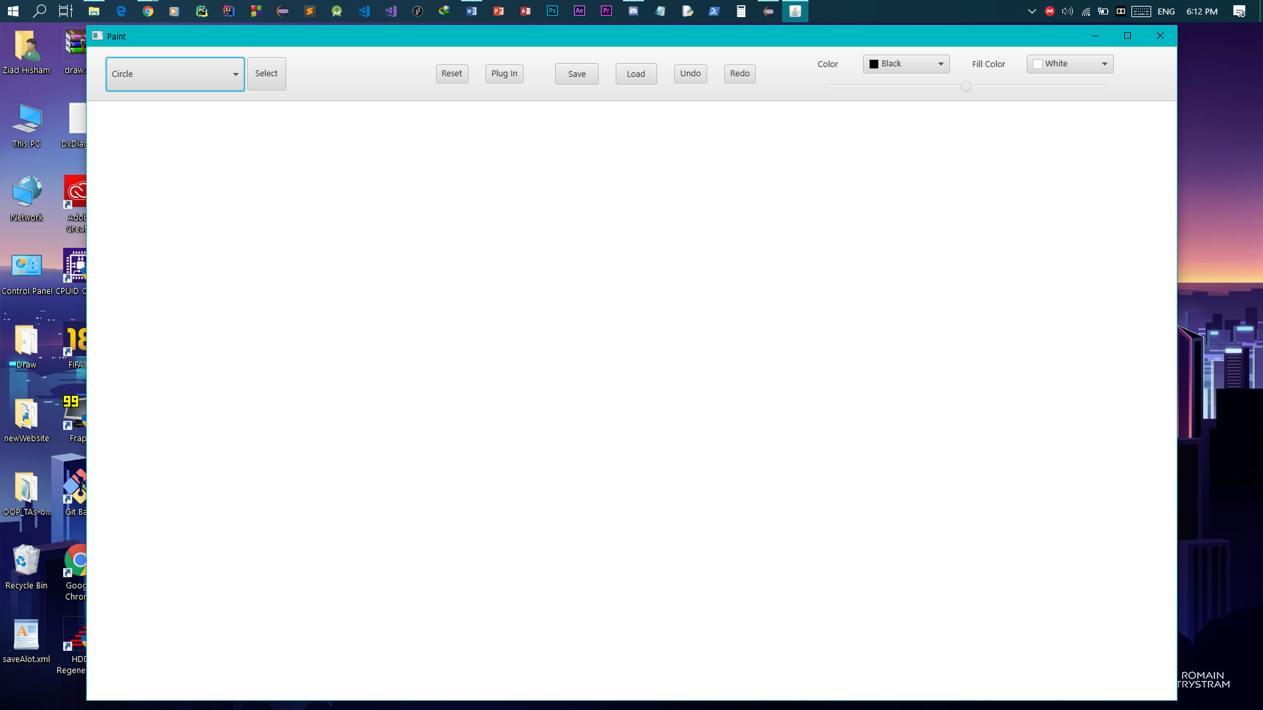

-Drawing a circle on the canvas.

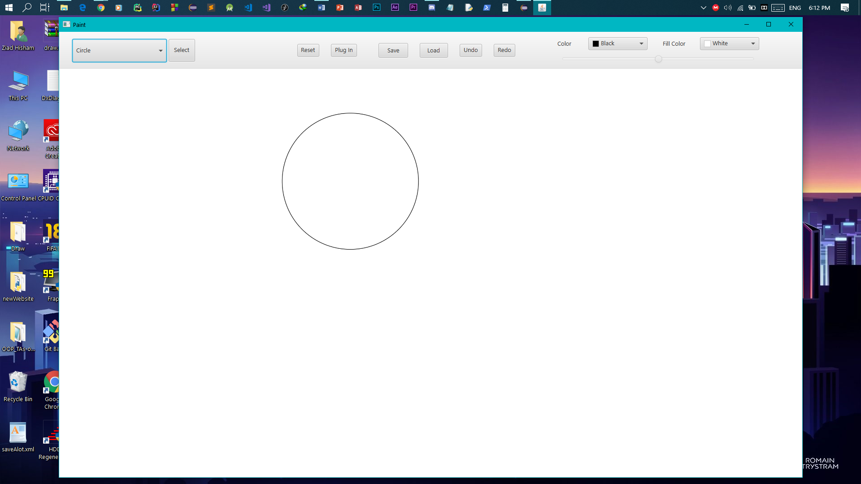

-the combo box containing the shapes.

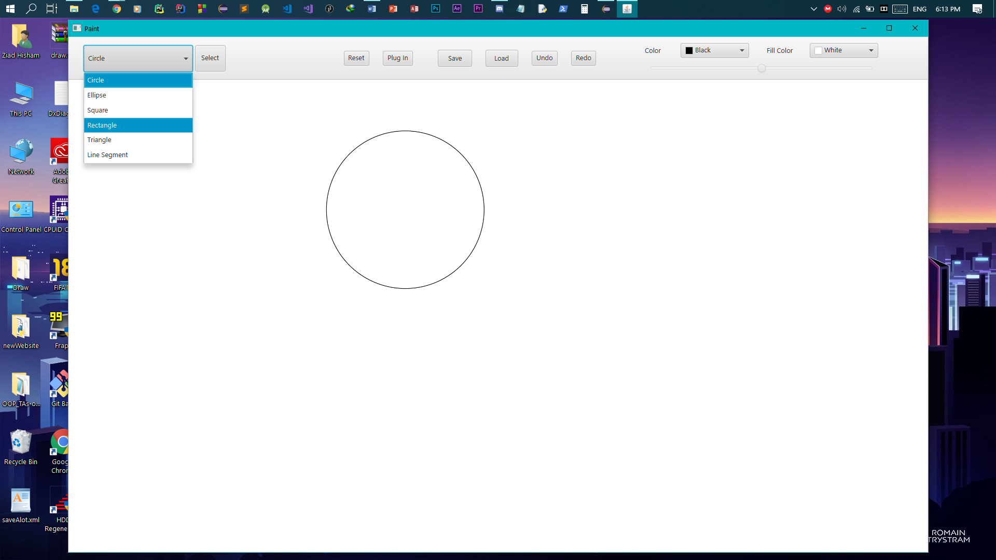

-choosing the fill color of the rectangle we want to draw.

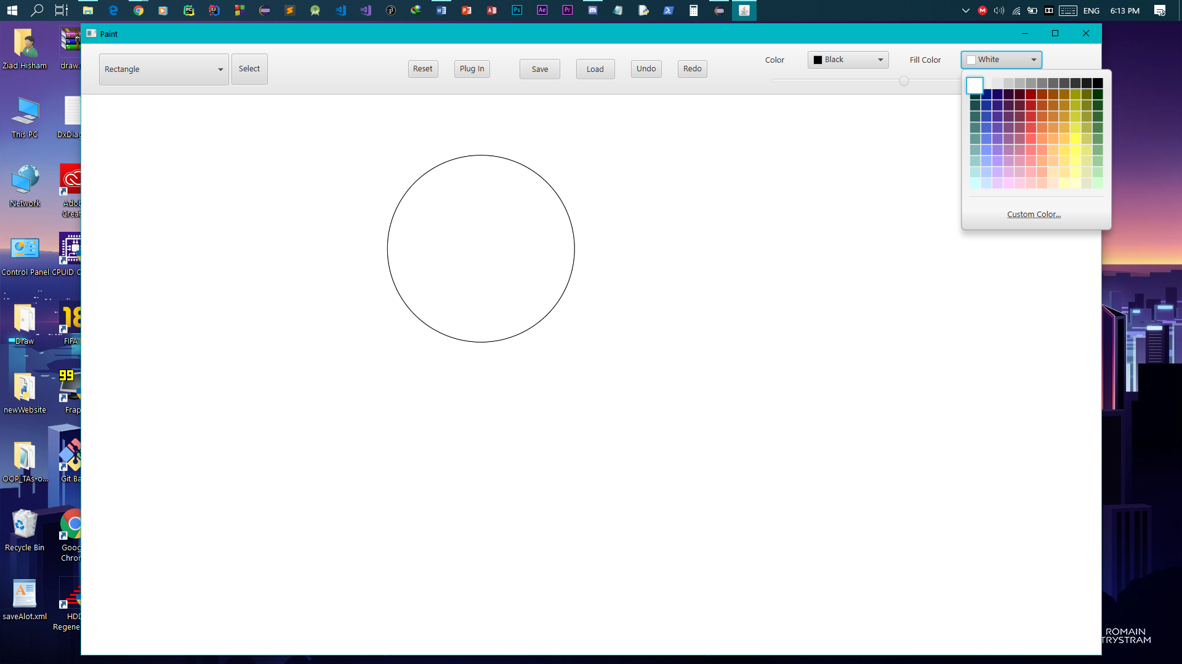

-drawing the rectangle.

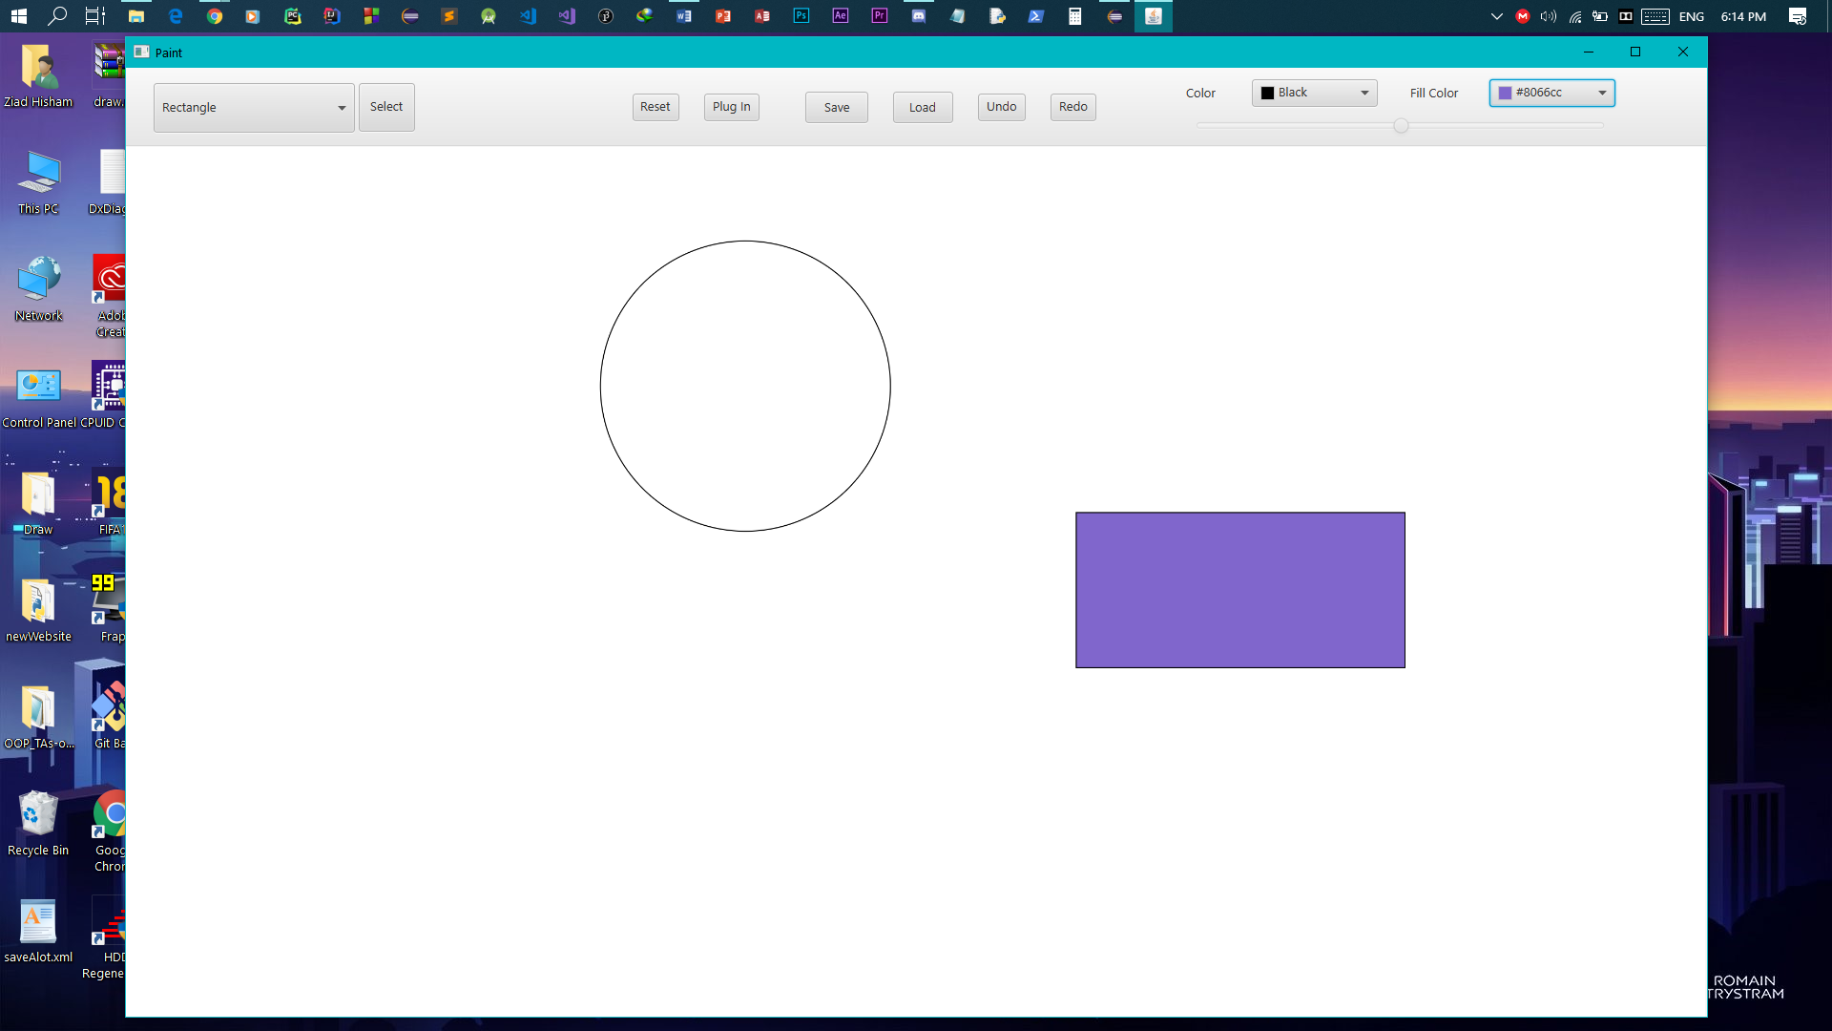

-drawing a triangle.

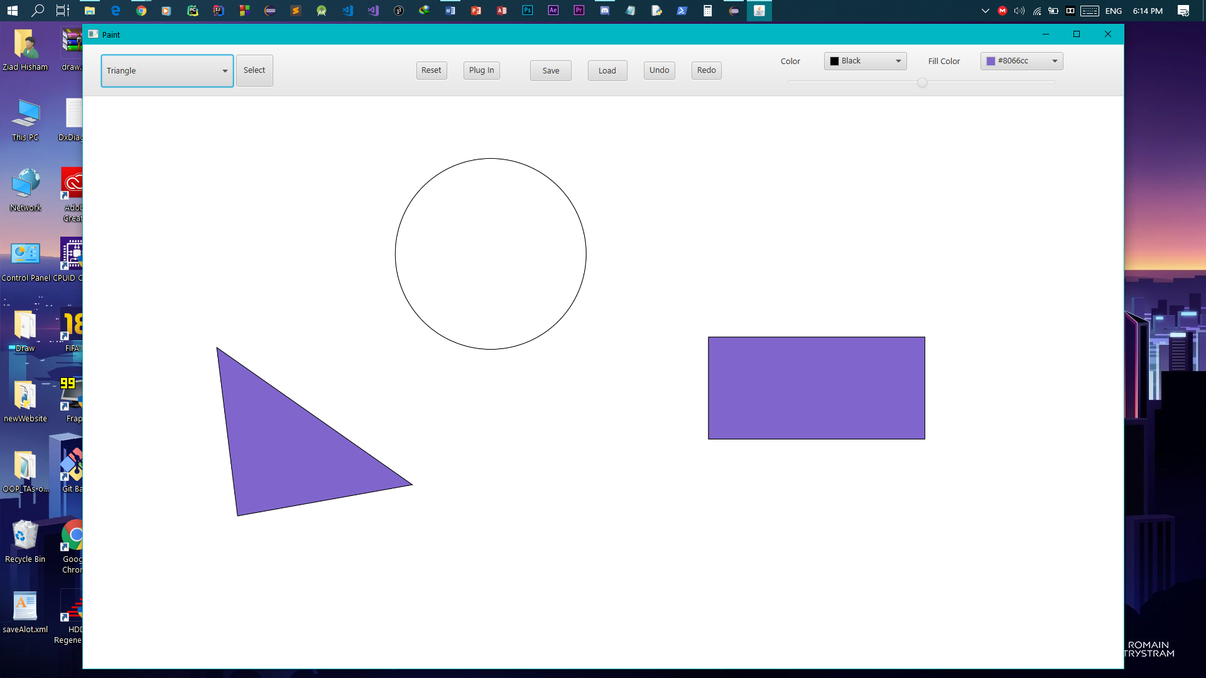

-after you press the Select button.

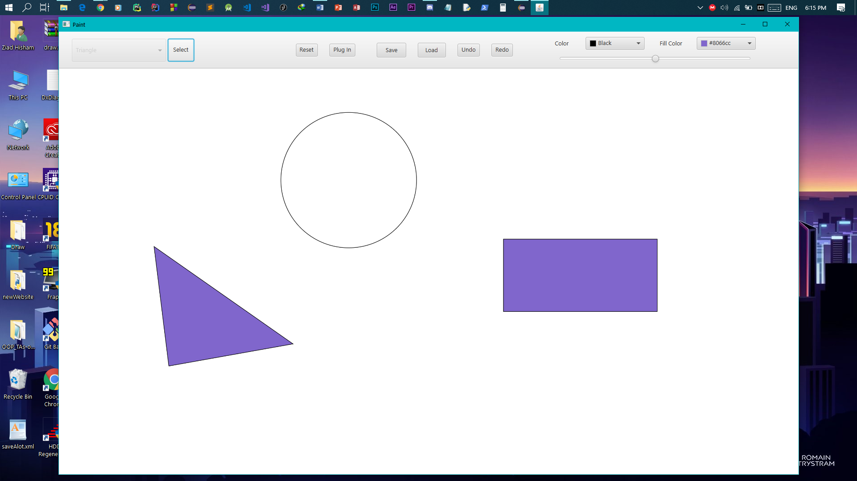

-we select the triangle and choose a new fill color for it.

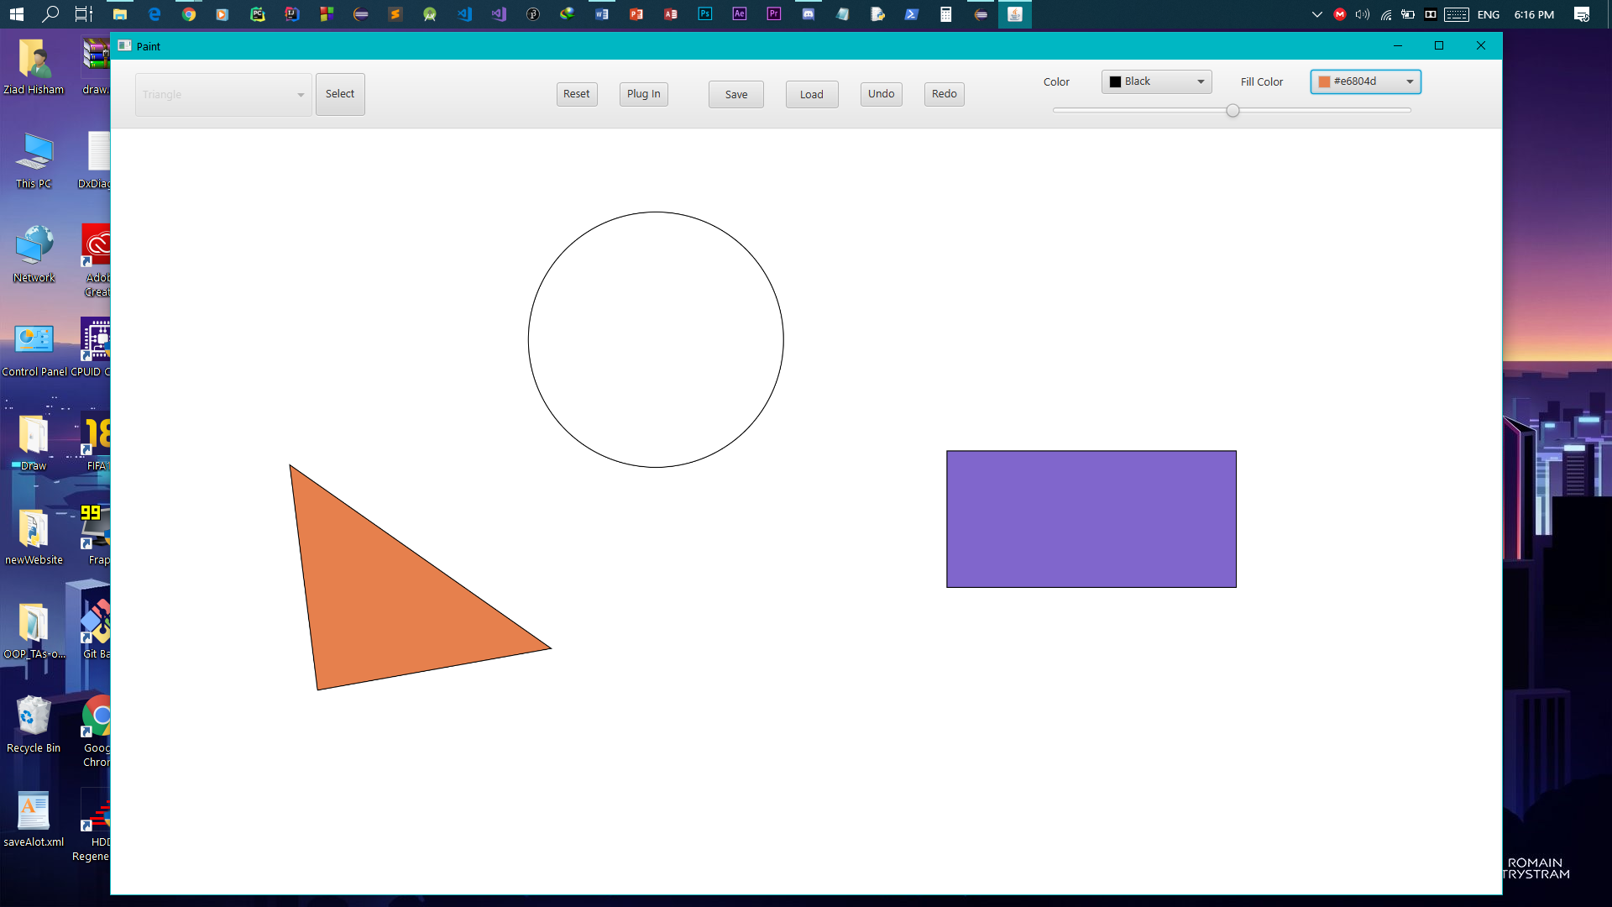

-we select the circle and change the color of the border.

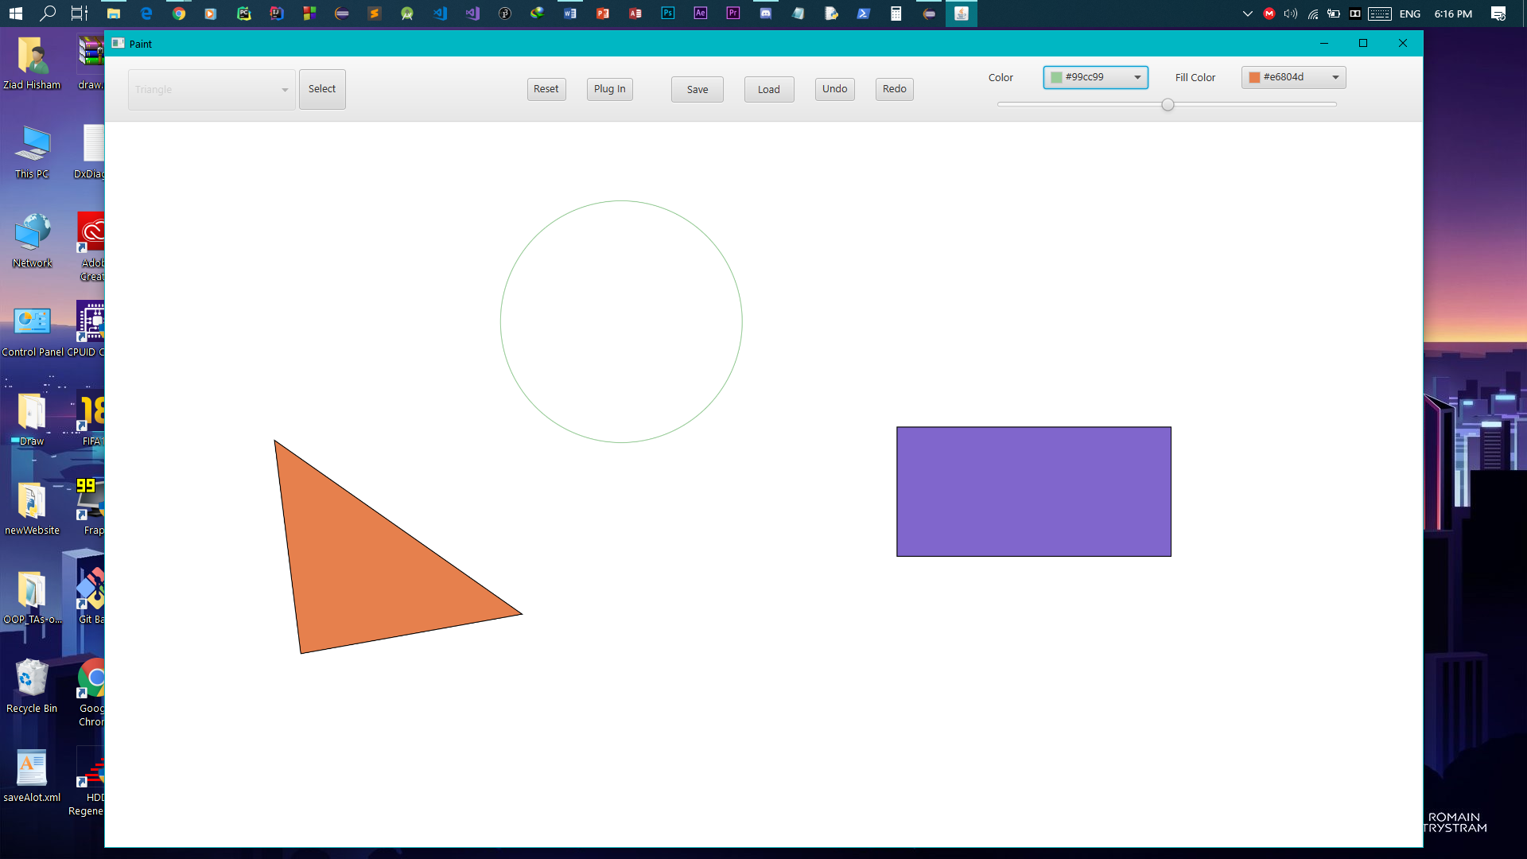

-we moved the rectangle by dragging.

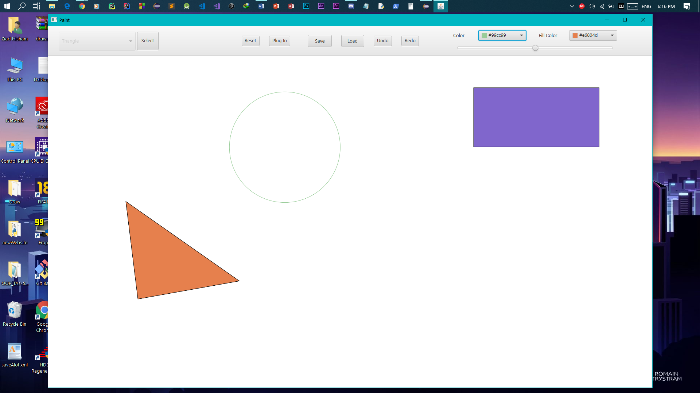

-we selected & resized the triangle using the slider.

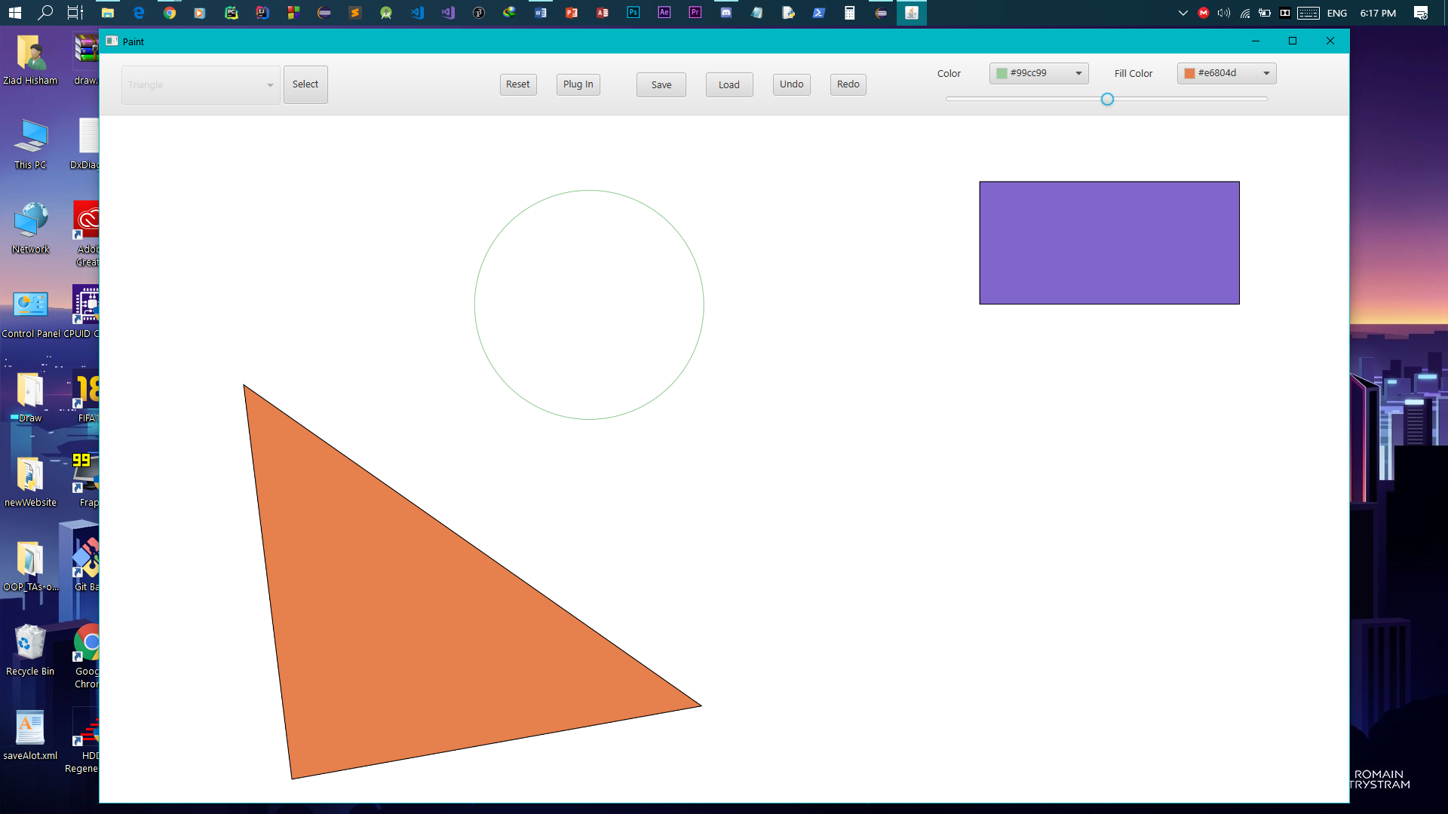

-we selected and changed the fill color of the circle.

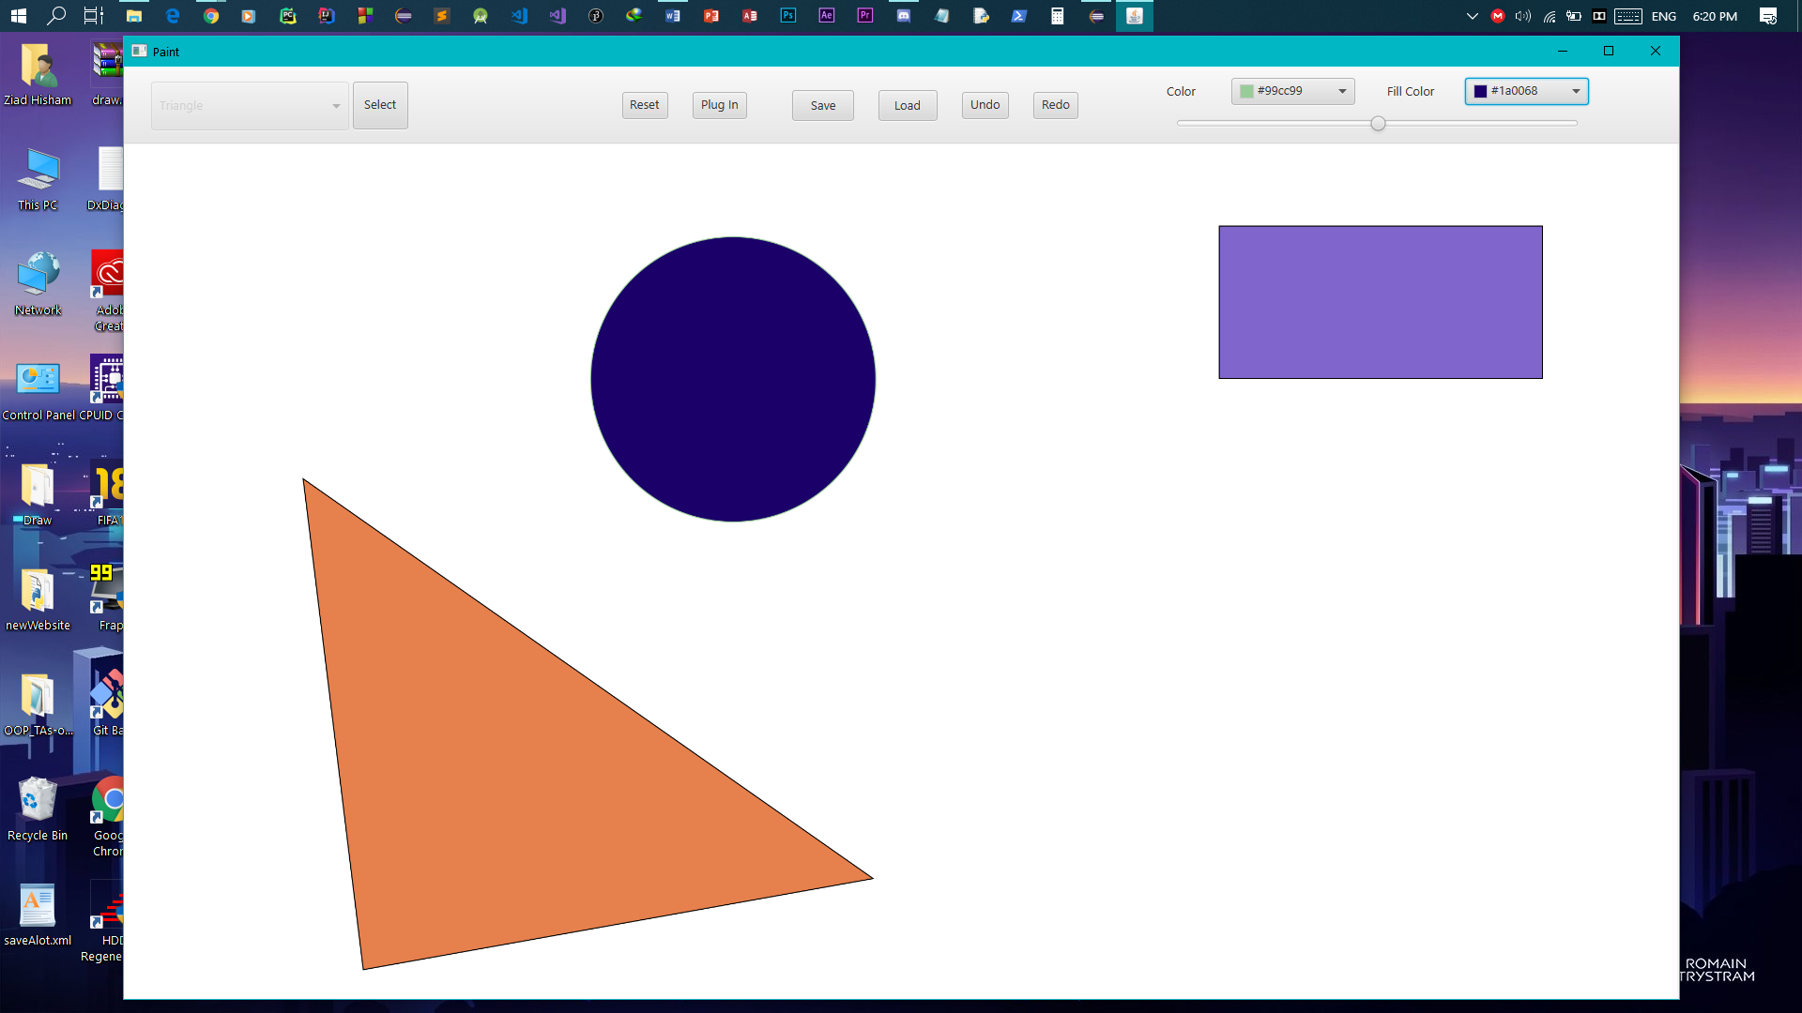

-we selected the circle and while pressing on the Ctrl key we selected the triangle and Ctrl+C to copy, then Ctrl+V to paste them.

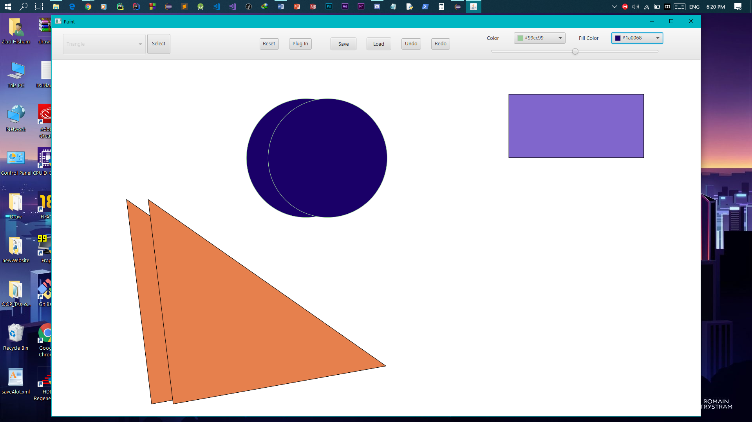

-we can now move them to any position we want.

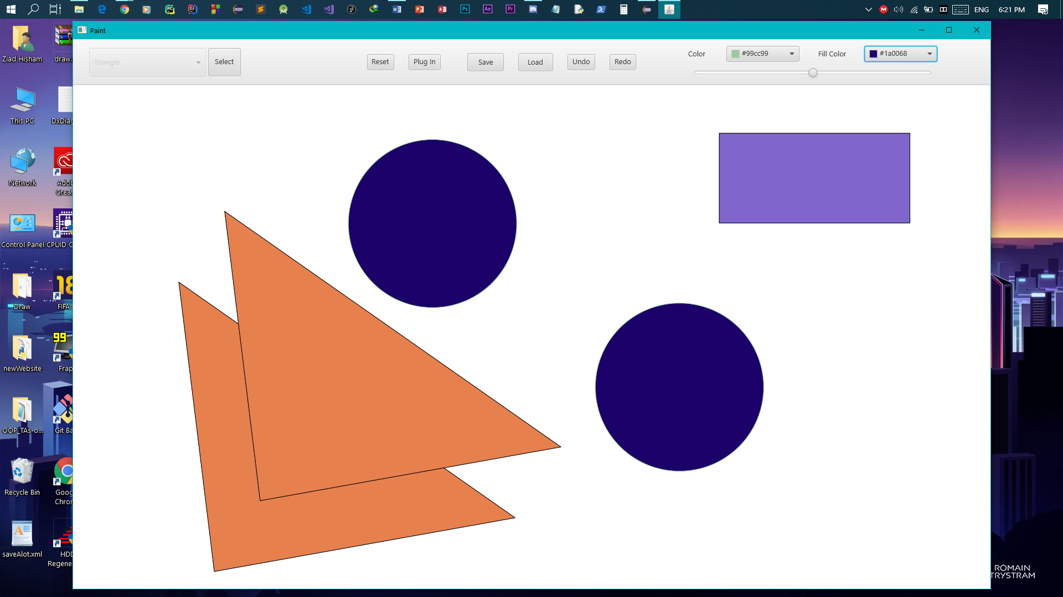

-we pressed on the save button to save our drawing.

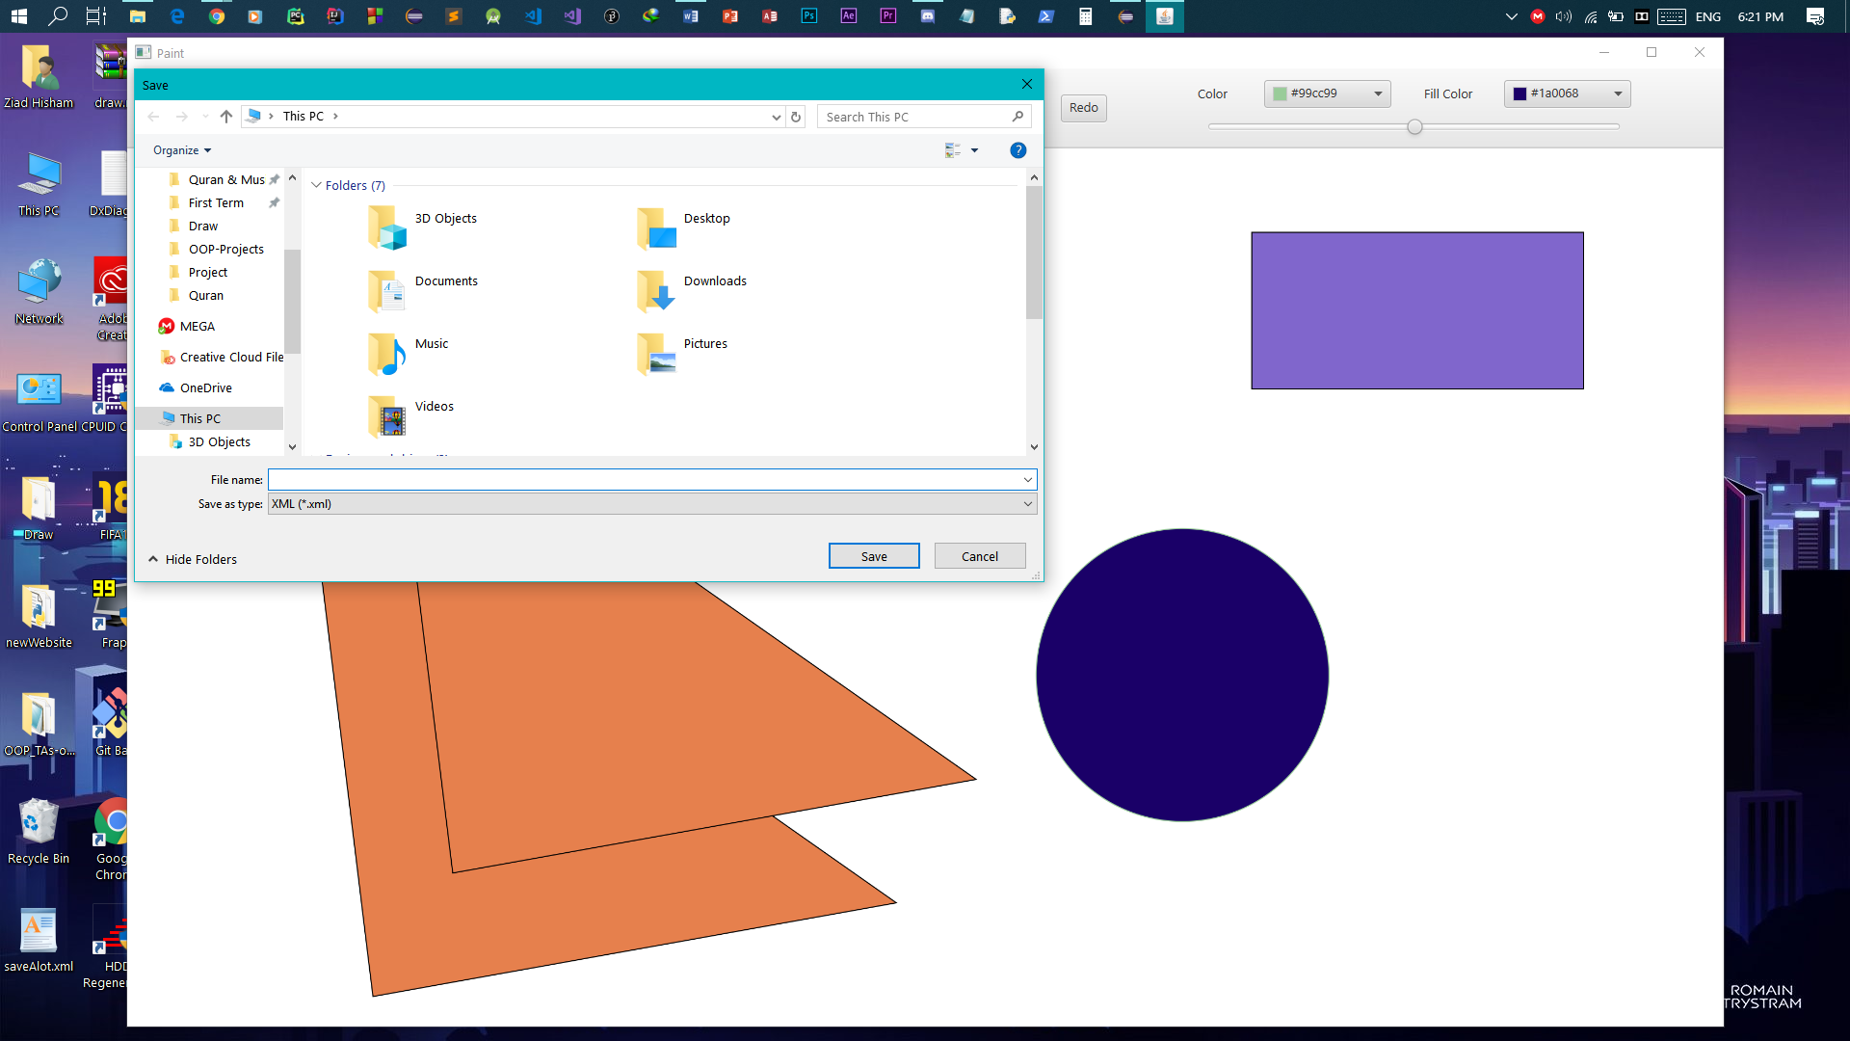

-choose the location and the type of the file.

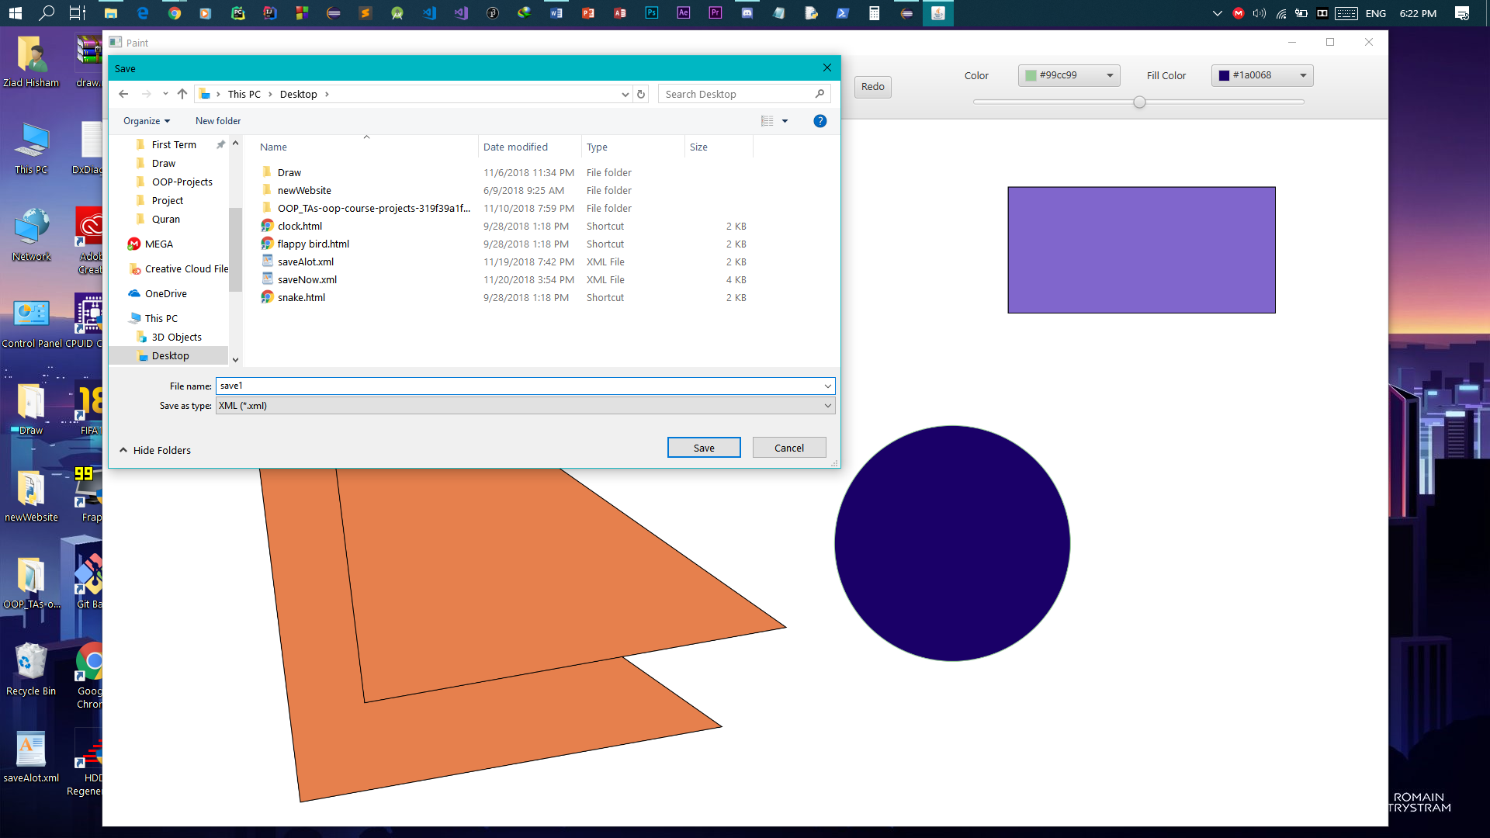

-we pressed the reset button which clean your workspace.

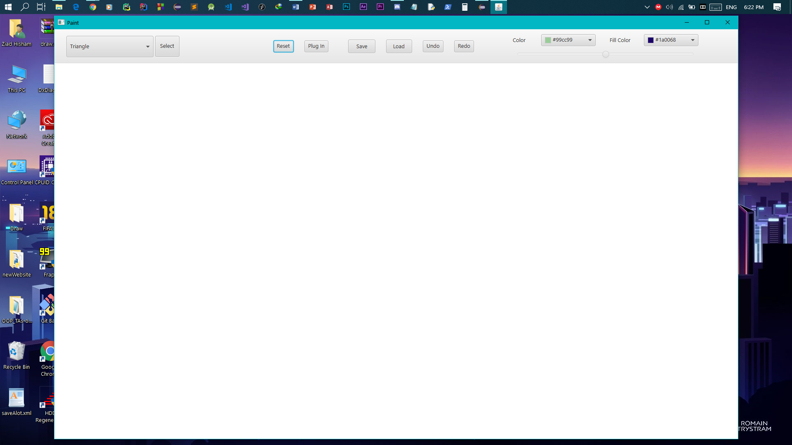

-we pressed on the load button to load the already saved file.

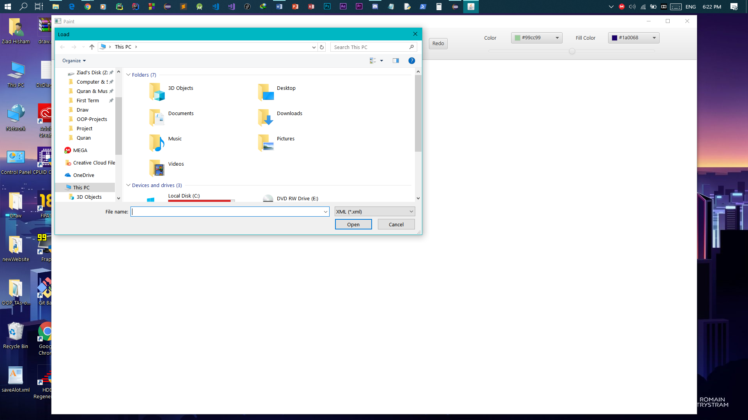

-browse to the file you want to load.

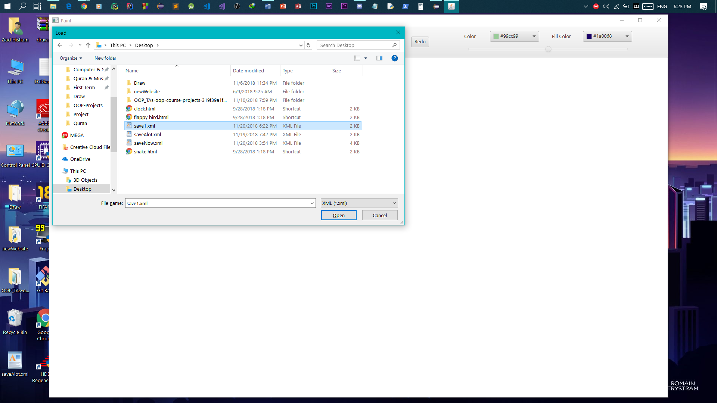

-the file is loaded and the shapes are drawn on the canvas.

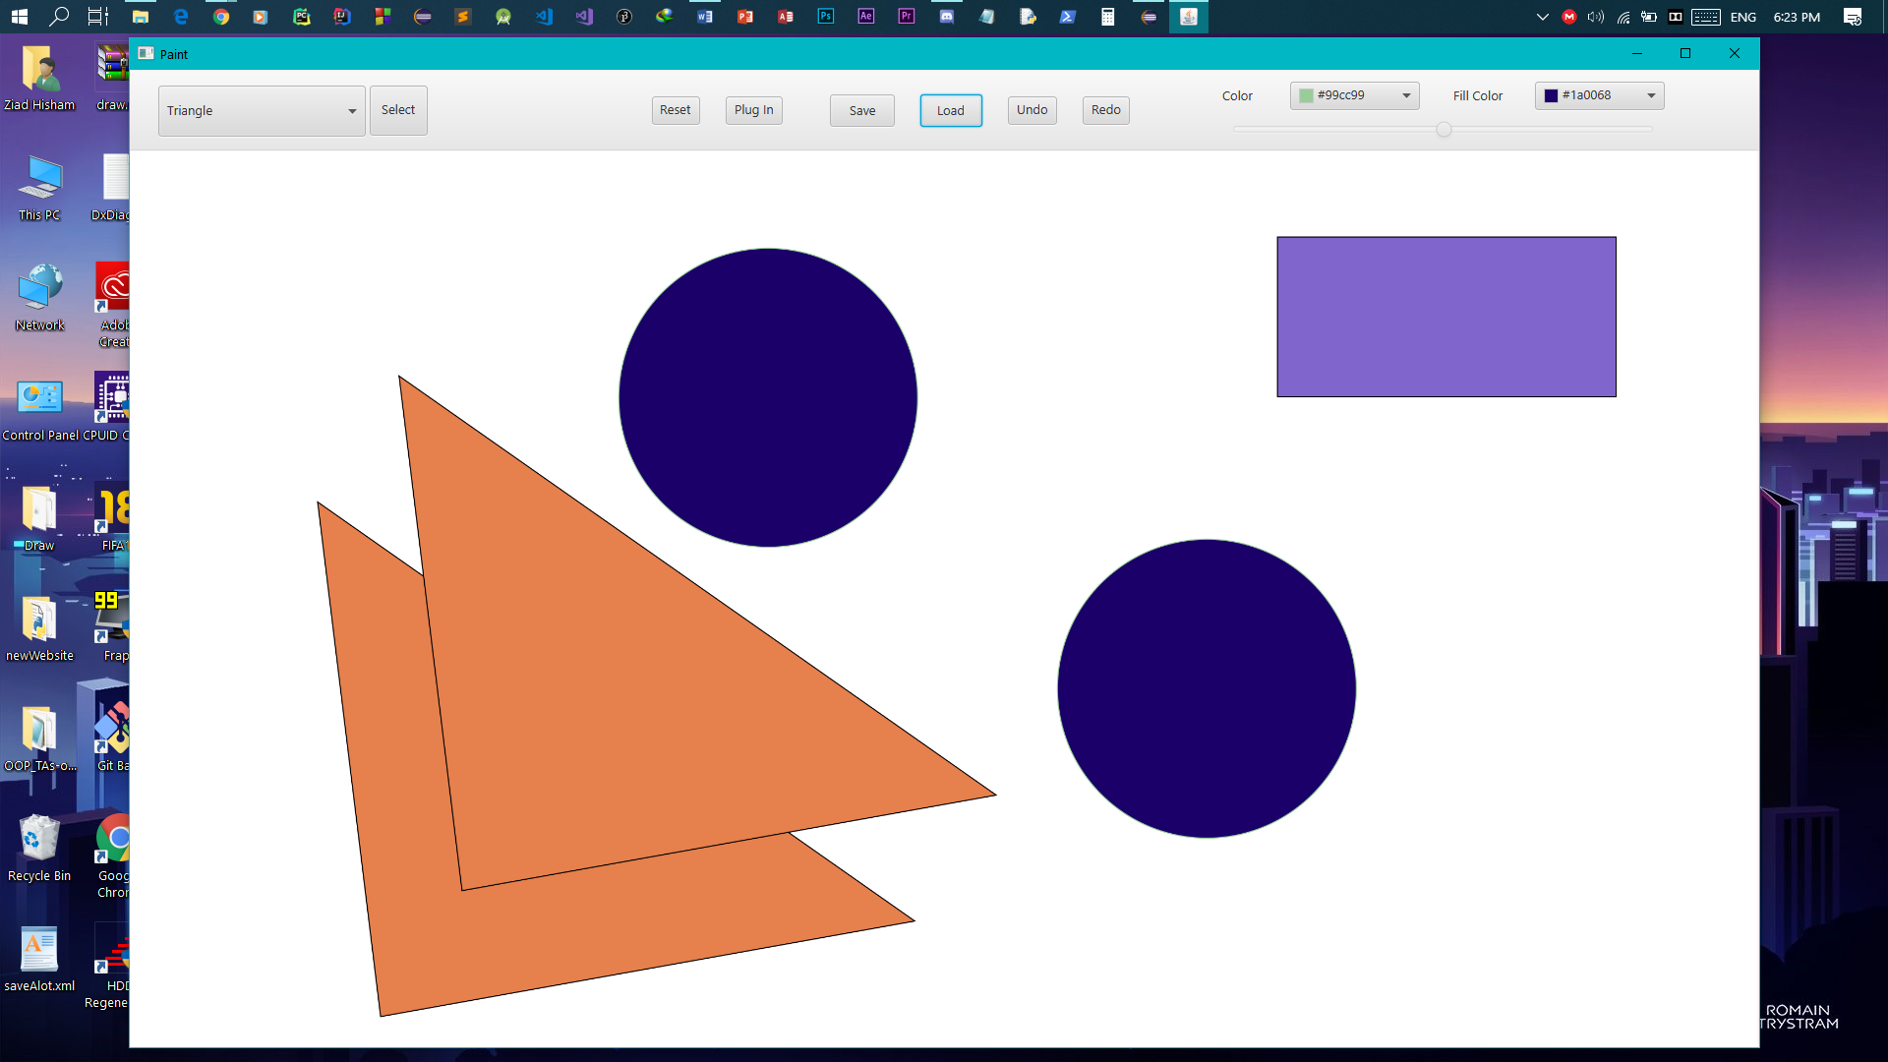

-we pressed on the plugin button to add a new shape.

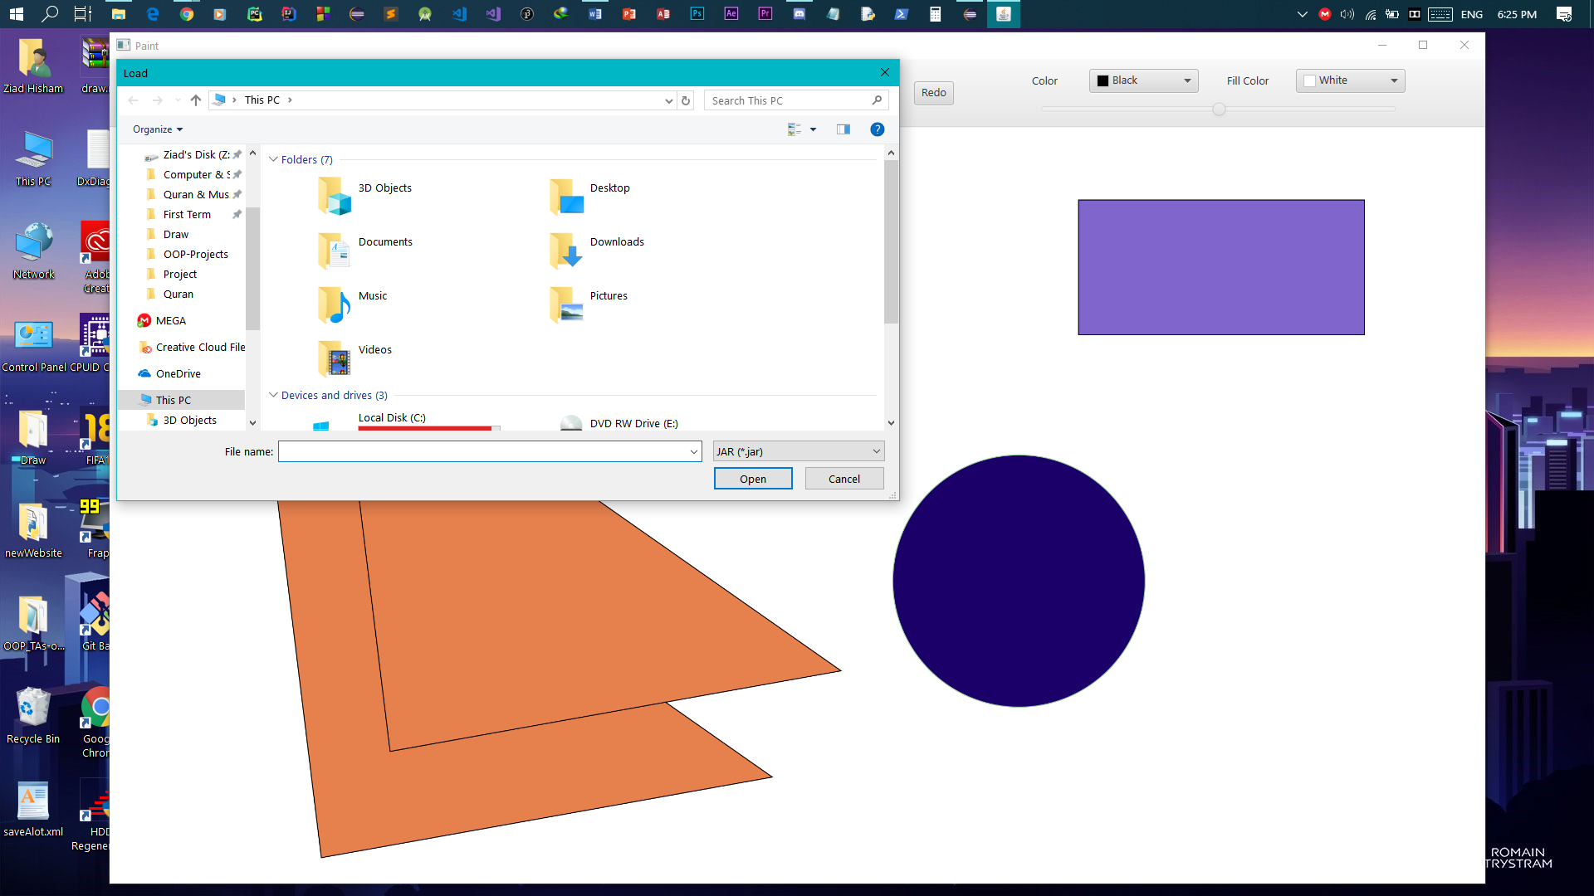

-we browsed to the jar file of the new shape.

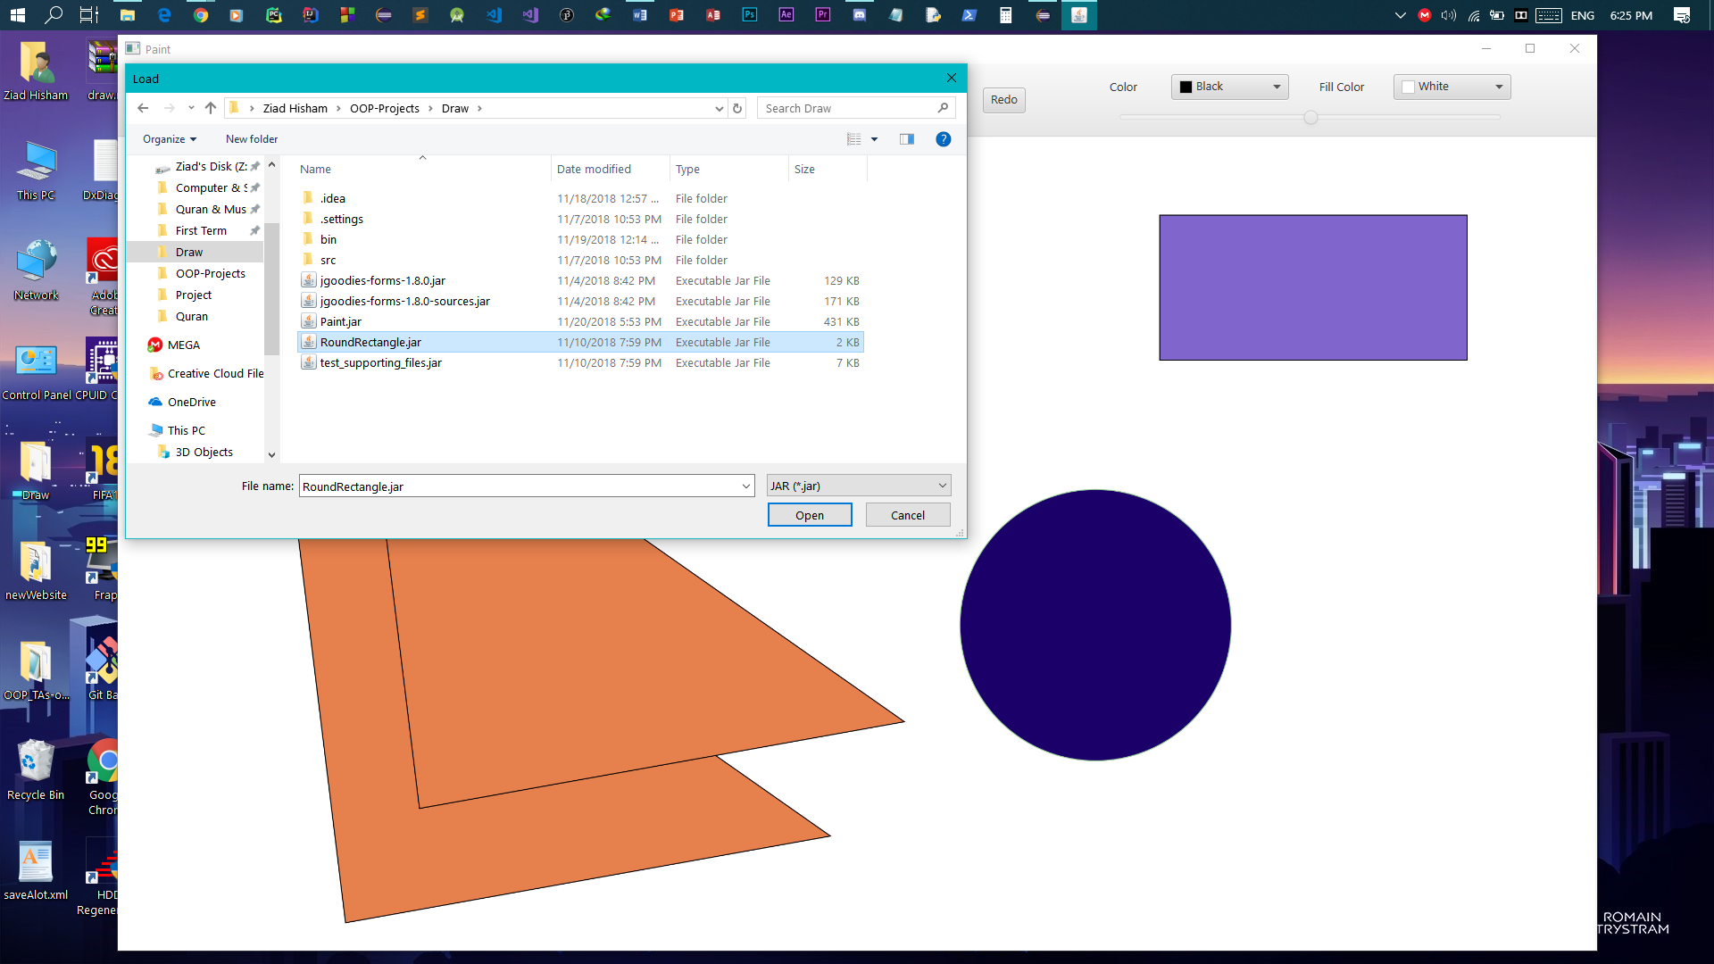

-now the new shape is added to the combo box of shapes and we can choose it to draw.

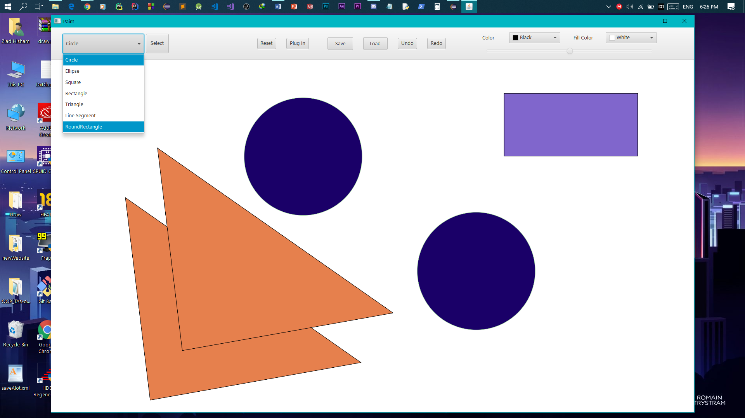

-because the shape is new to the application when you choose its position a dialog will ask you to enter its properties & if the shape supports javaFX Graphics it’ll be drawn.

